CLOUD-BASED FINANCIAL TRANSACTION PATTERN ANALYTICS
A Project Report Submitted in the partial fulfillment of the
requirements for the award of the degree of

BACHELOR OF TECHNOLOGY
In
DEPARTMENT OF COMPUTER SCIENCE ENGINEERING

By
CHANDRAHAS.U – 2320030041
NAGARJUNA.D – 2320090047
CHANDRA TEJA.P – 2320030313
SRIRAM.N – 2320030476
Under the Esteemed Guidance of

LECTURER NAME VINISHA VELTHURU



K L (Deemed to be) University

DEPARTMENT OF COMPUTER SCIENCE ENGINEERING


Declaration

The Project Report entitled “Education and Student Performance using Data using AI Tools” is a record of Bonafide work of team members Chandrahas.U – 2320030041, Nagarjuna.D – 2320090047, Chandra Teja.P – 2320030313, Sriram.N – 2320030476 submitted in partial fulfilment for the award of B. Tech in Computer Engineering to K L University. The results embodied in this report have not been copied from any other departments/University/Institute.

Chandrahas.U – 2320030041
Nagarjuna.D – 2320090047
Chandra Teja.P – 2320030313
Sriram.N – 2320030476

K L (Deemed to be) University DEPARTMENT OF COMPUTER SCIENCE ENGINEERING


Certificate

This is to certify that the project-based report entitled “Education and Student Performance using Data using AI Tools” is a Bonafide work carried out and submitted by Chandrahas.U – 2320030041, Nagarjuna.D – 2320090047, Chandra Teja.P – 2320030313, Sriram.N – 2320030476 in partial fulfilment of the requirements for the award of the degree of Bachelor of Technology in Computer Science Engineering, at K L (Deemed to be University), during the academic year 2025–2026.

Signature of the Supervisor

Signature of the HOD Signature of the External Examine

ACKNOWLEDGEMENT
The success in this project would not have been possible but for the timely help and guidance rendered by many people. Our wish to express my sincere thanks to all those who has assisted us in one way or the other for the completion of my project.

Our greatest appreciation to my guide, Vinisha Velthuru, Department of Computer Science which cannot be expressed in words for his tremendous support, encouragement and guidance for this project.

We express our gratitude to Dr.N. Sirisha, Head of the Department for Computer Science Engineering for providing us with adequate facilities, ways and means by which we can complete this project-based Lab.

We thank all the members of teaching and non-teaching staff members, and who have assisted me directly or indirectly for successful completion of this project. Finally, I sincerely thank my parents, friends and classmates for their kind help and cooperation during my work.

Chandrahas.U – 2320030041
Nagarjuna.D – 2320090047
Chandra Teja.P – 2320030313
Sriram.N – 232003047

TABLE OF CONTENTS

S.No | Contents | Page no
1 | Abstract | 6
2 | Introduction | 7
3 | Literature survey | 9
4 | Hardware and Software requirements | 12
5 | Implementation | 16
6 | Experimentation and Code | 18
7 | Results | 21
8 | Conclusion | 25
19 | References | 26

ABSTRACT

The College Student Performance Dashboard is a full-stack web application designed to monitor,
analyze, and predict student academic performance through an intelligent, role-based system. The
platform integrates secure authentication, data analytics, and machine learning to provide actionable
insights for both administrators and students.

Built using Python and Flask for backend development, SQLite for database management, and HTML, CSS, and JavaScript for the frontend, the system ensures a responsive and user-friendly interface. Authentication is implemented using Flask-Login with Bcrypt password hashing, guaranteeing secure access control. The platform supports two user roles: Admin, who has full access including data management and analytics, and Student, who can securely view only their own academic data.

A key feature of the system is the integration of a Decision Tree Classifier (scikit-learn) that predicts
student performance (Pass/Fail) based on internal marks, external marks, attendance percentage, and
backlog count. The model provides confidence-based predictions, helping identify at-risk students early. Additional modules include performance analytics dashboards, placement eligibility checks, student wellness tracking, academic calendar management, and automated notifications.

The system also supports batch CSV import/export functionality for efficient data management. With its combination of secure architecture, real-time analytics, and AI-driven prediction capabilities, the College Student Performance Dashboard serves as a comprehensive academic monitoring solution aimed at enhancing institutional decision-making and improving student outcomes.

INTRODUCTION

In today’s digital era, educational institutions generate a massive volume of student-related data every day through attendance systems, internal assessments, external examinations, and academic records. Managing and analysing such large-scale educational data using traditional spreadsheet-based methods has become increasingly inefficient and error-prone. These static systems lack scalability, real-time insights, and predictive capabilities, making it difficult for educators to monitor student performance effectively.

To address these challenges, modern data analytics solutions leveraging Big Data and Artificial Intelligence have emerged as powerful tools for transforming raw educational data into meaningful insights. This project adopts a data-driven approach to process, analyse, and predict student performance using advanced technologies.

The project titled “Student Performance Analytics & Prediction System” focuses on analysing academic data through a modern data pipeline. The main objective of this project is to evaluate student performance, identify at-risk students, and assist educators in making informed decisions using intelligent analytics.

Problem Description and Objectives:
Educational institutions handle large volumes of student data, including attendance records, internal marks, external examination scores, and backlog information. Analysing this data using traditional methods such as spreadsheets is time-consuming, inefficient, and prone to inconsistencies. As the volume of data increases, identifying patterns in student performance, predicting academic outcomes, and detecting students at risk of failure becomes increasingly complex.

Manual analysis lacks the ability to provide real-time insights or predictive intelligence. Educators often struggle to identify struggling students early enough to take corrective action. Additionally, there is no centralized system to efficiently manage, process, and visualize student data in a meaningful way.

To overcome these challenges, this project implements a modern data analytics pipeline that combines Big Data processing, machine learning, and visualization techniques. The system leverages tools like Apache Spark for distributed data processing, enabling efficient handling of large datasets, and uses optimized storage formats like Parquet for faster analytics.

The main objective of this project is to analyse student data and extract meaningful insights that support academic decision-making. It aims to process raw student data, compute performance metrics such as attendance trends and academic scores, and classify students based on risk levels (e.g., Critical, Moderate, Stable). Another key objective is to build a predictive model that can determine whether a student is likely to pass or fail based on key academic indicators.

The project also focuses on identifying patterns such as the relationship between attendance and performance, department-wise academic trends, and factors influencing student success. Additionally, it includes visualization techniques through an interactive dashboard, enabling educators to easily interpret insights using charts, graphs, and real-time metrics.

Furthermore, the system incorporates features such as student search, eligibility checking, burnout detection, and real-time monitoring through time-series dashboards. These features help educators take proactive measures to support students.

Through this project, the importance of integrating Big Data technologies, machine learning, and modern data architectures in the education sector is clearly demonstrated, providing a scalable, efficient, and intelligent solution for student performance analysis.

LITERATURE SURVEY

The rapid digitalization of educational institutions has led to a significant increase in the volume of student data generated through attendance systems, internal assessments, examinations, and academic records. Traditional data management techniques, such as spreadsheets and manual record-keeping, are no longer sufficient to handle such large-scale and continuously growing datasets. As a result, Big Data analytics and machine learning techniques have emerged as essential tools for efficiently analysing educational data and improving academic outcomes. Several researchers have explored the use of distributed computing, predictive analytics, and intelligent systems to enhance student performance monitoring and decision-making.

Student performance analytics has become a key research area due to its importance in identifying at-risk students, understanding learning patterns, and improving institutional efficiency. With the adoption of modern data architectures, organizations can store large datasets and perform complex computations in a scalable and efficient manner. Technologies such as Apache Spark, data lake architectures, and machine learning frameworks have played a crucial role in transforming traditional academic analysis into intelligent, data-driven systems.

Big Data Processing in Educational Systems

Big data technologies have significantly transformed how educational data is processed and analysed. According to Chen et al. (2012), big data analytics enables institutions to extract meaningful insights from large and complex datasets. Educational data, which includes attendance, marks, and behavioural patterns, can be processed efficiently using distributed computing frameworks.

Apache Spark has become one of the most widely used tools for large-scale data processing due to its speed and in-memory computation capabilities. Zaharia et al. (2016) demonstrated that Spark significantly reduces processing time compared to traditional data processing systems. It supports both batch and real-time processing, making it suitable for academic analytics where timely insights are essential.

Researchers have shown that using distributed processing frameworks improves scalability, reduces computational overhead, and enables institutions to handle increasing volumes of student data effectively.

Data Lakehouse Architecture in Analytics

Modern analytics systems increasingly adopt the Data Lakehouse architecture, which combines the flexibility of data lakes with the performance of data warehouses. This architecture organizes data into multiple layers such as raw, processed, and analytical datasets.

Studies indicate that separating data into layers (e.g., Bronze, Silver, Gold) improves data quality, consistency, and accessibility. Raw data is first ingested, then cleaned and structured, and finally optimized for analytics and machine learning. This layered approach enhances performance and simplifies data management.

Researchers have emphasized that optimized storage formats such as Parquet significantly improve query performance and reduce storage requirements, making them ideal for analytics and dashboard applications.

Machine Learning in Student Performance Prediction

Machine learning has been widely applied in educational data mining to predict student outcomes and identify factors affecting academic success. Romero and Ventura (2010) highlighted that predictive models can help educators identify students at risk of failure and take proactive measures.

Various classification algorithms such as Decision Trees, Logistic Regression, and Random Forests have been used to predict student performance. Among these, Decision Trees are particularly popular due to their interpretability and ease of implementation.

Research shows that factors such as attendance, internal marks, external marks, and backlog history play a significant role in determining student performance. Machine learning models trained on these features can achieve high accuracy in predicting whether a student will pass or fail.

Risk Detection and Academic Intervention Systems

Identifying at-risk students is a critical application of educational analytics. Similar to anomaly detection in other domains, students showing unusual academic patterns—such as low attendance, declining marks, or increasing backlogs—can be flagged for intervention.

Researchers have proposed rule-based systems and predictive models to classify students into categories such as high-risk, moderate-risk, and low-risk. Rule-based approaches are simple and interpretable, while machine learning models provide higher accuracy and adaptability.

Early detection systems enable educators to provide timely support, reducing dropout rates and improving overall academic performance. Studies suggest that combining rule-based logic with predictive analytics leads to more effective intervention strategies.

Conclusion

The literature clearly demonstrates that Big Data analytics and machine learning are essential for modern educational systems. From early data analysis techniques to advanced predictive models and intelligent dashboards, research consistently highlights the advantages of scalable computing and data-driven decision-making.

This project builds upon these research findings by implementing a Student Performance Analytics & Prediction System using Apache Spark, machine learning models, and a Data Lakehouse architecture. By analysing student data, predicting outcomes, identifying at-risk students, and visualizing insights through an interactive dashboard, the project demonstrates the practical application of concepts discussed in existing literature and highlights the effectiveness of modern data analytics in the education sector.

HARDWARE AND SOFTWARE REQUIREMENTS:

Hardware Specifications
The Student Performance Analytics & Prediction System does not require extremely high-end hardware, but since parts of the project (such as Apache Spark processing, machine learning training, and dashboard hosting) are executed locally, a moderately capable system is recommended for smooth performance.

Processor
A system with an Intel Core i3 processor or equivalent is sufficient to run the project. However, for better performance—especially while running Apache Spark jobs and Flask server simultaneously—an Intel Core i5 or higher is recommended.

RAM
A minimum of 4 GB RAM is required to run the project. However, 8 GB RAM or more is strongly recommended for:
- Running Apache Spark efficiently
- Handling machine learning model training
- Managing multiple processes (Flask server, database, browser)

Storage
At least 1 GB of free disk space is required for:
- Project files and datasets
- SQLite database (students.db)
- Generated Parquet files
- Model files and visual outputs
Additional storage may be needed depending on dataset size and logs.

Graphics
No dedicated graphics card is required. Integrated graphics are sufficient, as the project focuses on data processing, analytics, and visualization dashboards, not heavy graphical rendering.
Operating System
The project is compatible with:
- Windows
- Linux
- macOS
Since the system uses cross-platform tools like Python, Spark, and Flask, it can run on any modern operating system without major changes.

Software Requirements
The project uses a combination of Big Data tools, machine learning libraries, and web technologies to build a complete analytics pipeline.

Programming Language
- Python (Version 3.8 or above)
Python is the core language used for:
- Data generation and processing
- Machine learning model development
- Backend server implementation

Libraries and Frameworks
The following libraries are used:
- Apache Spark (PySpark)
Used for large-scale data processing and ETL operations
- Pandas
Used for data manipulation and preprocessing
- NumPy
Used for numerical computations
- Scikit-learn
Used for building the Decision Tree model and predictive analytics
- Matplotlib / Seaborn
Used for generating visual reports such as feature importance graphs
- Flask
Used to build the web-based dashboard and backend APIs

Database
- SQLite
Used as the operational database (Silver Layer)
Stores structured student data for fast access by the web application

Big Data & Storage Technologies
- Apache Spark
Handles large-scale data processing and transformation
- Parquet Files
Used for optimized storage in the Gold Layer
Enables faster analytics and machine learning

Time-Series & Monitoring Tools
- InfluxDB
Used for storing time-series data related to student performance trends
- Grafana
Used for real-time visualization and monitoring dashboards
- Docker (via docker-compose)
Used to deploy and manage InfluxDB and Grafana services

Development Environment
- Visual Studio Code / PyCharm (Optional)
Used for coding and debugging
- Jupyter Notebook (Optional)
Used for experimentation and model development
- Web Browser (Google Chrome / Microsoft Edge)
Used to access the Flask dashboard and Grafana interface

Visualization Tools
- Chart.js & ApexCharts
Used in the web dashboard for interactive charts
- Grafana Dashboards
Used for time-series analytics and monitoring
These tools help visualize:
- Student performance trends
- Attendance vs marks correlation
- Risk classification
- Department-wise analysis

Summary
With the above hardware and software configuration, the Student Performance Analytics & Prediction System can be executed efficiently. While moderate local resources are required, the use of Apache Spark for distributed processing, machine learning for prediction, and interactive dashboards for visualization ensures high performance and scalability.
The system demonstrates how modern technologies can be integrated to build a powerful, data-driven solution for improving student outcomes and enabling smarter academic decision-making.

IMPLEMENTATION

Implementation of Student Performance Analytics & Prediction System
The implementation of the Student Performance Analytics & Prediction System focuses on analysing large-scale student data using modern data engineering, machine learning, and visualization techniques. The system is designed to efficiently store, process, analyse, and visualize academic data using tools such as Apache Spark, SQLite, and Flask.
The complete implementation follows a structured pipeline based on a Data Lakehouse architecture, where data flows through multiple stages including data generation, storage, processing, analytics, machine learning, and visualization.
The implementation process is divided into multiple stages, each contributing to accurate analysis and intelligent decision-making.

1. Data Representation and Dataset Description
The dataset used in this project consists of synthetically generated student records that simulate real-world academic data. Each record represents a student and includes various attributes that influence academic performance.
The dataset includes the following key attributes:
- Student ID – Unique identifier for each student
- Name – Student name
- Department – Academic department
- Attendance (%) – Attendance percentage
- Internal Marks – Scores obtained in internal assessments
- External Marks – Scores obtained in final examinations
- Backlogs – Number of failed subjects
- Total Score – Combined academic score
- Risk Level – Categorization (Critical, Moderate, Stable)
The dataset is initially generated as a CSV file (Bronze Layer) and later processed into structured and analytical formats.

2. Establishing the Data Environment
The implementation environment is built using a combination of local and distributed technologies.
SQLite Database (Silver Layer)
- Stores structured student data
- Acts as the primary data source for the web application
- Ensures efficient querying and data consistency
Apache Spark (Gold Layer Processing)
- Used as the main analytics engine
- Provides:
  - Distributed data processing
  - High-speed computation
  - Scalability for large datasets
Parquet Storage
- Processed data is stored in Parquet format
- Enables faster analytics and efficient storage

3. Data Generation and Preprocessing
Data Generation
- The dataset is generated using a custom script
- Realistic academic patterns are simulated:
  - Low attendance → Poor performance
  - High backlogs → Increased risk
Data Migration
- CSV data is imported into the SQLite database
- Ensures structured storage for application use
Preprocessing Steps
- Handling missing values
- Removing duplicate records
- Validating data types
- Formatting columns for analysis
This step ensures that the dataset is clean and ready for processing.

4. Data Processing and Analytical Computation (Apache Spark)
After preprocessing, Apache Spark performs large-scale data transformations and analytics.
Academic Performance Analysis
The system analyses:
- Attendance distribution
- Marks distribution (internal & external)
- Department-wise performance trends
Derived Metrics
Academic Health Score
- A weighted score based on:
  - Attendance
  - Internal marks
  - External marks
Intervention Priority
- Classifies students into:
  - Critical
  - Moderate
  - Stable
These metrics help educators quickly identify students needing attention.

5. Machine Learning-Based Performance Prediction
To enhance the system, a Decision Tree Classifier is implemented using Scikit-learn.
Model Features
- Attendance
- Internal Marks
- External Marks
- Backlogs
Model Process
- Dataset is split into training and testing sets
- Model is trained to predict:
  - Pass / Fail outcome
Results
- Achieves high accuracy (~90%)
- Identifies key influencing factors:
  - External marks (most important)
  - Attendance
  - Backlogs
The model helps in predicting student outcomes and enabling early intervention.

6. Time-Series Monitoring and Observability
The system includes real-time monitoring using:
- InfluxDB – Stores time-series data
- Grafana – Visualizes trends over time
- Docker – Manages deployment of services
Capabilities
- Track performance trends across semesters
- Monitor changes in pass rates
- Analyse long-term academic behaviour

7. Visualization and Dashboard Implementation
The system includes an interactive Flask-based web dashboard for user interaction.
Dashboard Features
Academic Overview
- Total students
- Average attendance
- Pass rate
- At-risk student count
Visual Analytics
- Grade distributions
- Department-wise performance
- Correlation heatmaps
Burnout Detection
- Identifies students under academic stress
- Generates a watchlist
Student Search
- Retrieve individual student profiles
Eligibility Checker
- Determines exam eligibility based on rules:
  - Attendance > 75%
  - Marks > 60
  - Backlogs < 2
Data Management
- Add new student records
- Upload CSV datasets
- Export reports for at-risk students
Grafana Integration
- Embedded real-time analytics dashboard

8. Output and Performance Evaluation
The system generates:
- Student performance summaries
- Risk classification reports
- Predictive outcomes (Pass/Fail)
- Interactive visual dashboards
- Time-series analytics
Performance Benefits
- Faster data processing using Apache Spark
- Scalable architecture using Data Lakehouse model
- Accurate predictions using machine learning
- Improved decision-making through visualization

Conclusion
The implementation demonstrates how modern technologies such as Apache Spark, machine learning, and interactive dashboards can be integrated to build an intelligent academic analytics system. Compared to traditional methods, the system provides better scalability, faster processing, and predictive insights, enabling educators to take proactive actions and improve student outcomes.

EXPEREMENTATION AND CODE:

Code Structure
The project was implemented using Python, Apache Spark, and Flask-based web technologies. The code is organized into multiple modules, each responsible for a specific stage of the data pipeline:
- Data Loading:
Student data is generated as CSV files and loaded into a SQLite database as well as Spark DataFrames for further processing.
- Data Preprocessing:
The dataset is cleaned and formatted by handling missing values, removing duplicates, and validating data types to ensure consistency and accuracy.
- Analytics Module:
Performs academic analysis such as:
  - Attendance distribution
  - Marks analysis (internal and external)
  - Department-wise performance
  - Calculation of derived metrics like Academic Health Score and Intervention Priority
- Prediction Module (Machine Learning):
Implements a Decision Tree Classifier to predict student outcomes (Pass/Fail) based on features like attendance, marks, and backlogs.
- Risk Detection Logic:
Identifies at-risk students using rule-based conditions and computed metrics (e.g., low attendance, high backlogs, low scores), categorizing them into Critical, Moderate, or Stable groups.
- Visualization:
Interactive dashboards are built using Flask, Chart.js, and ApexCharts, displaying:
  - Performance trends
  - Grade distributions
  - Correlation heatmaps
  - At-risk student insight

Experimentation

Steps Performed
- Data Generation and Loading
Generated a synthetic dataset of 1,000 student records and loaded it into a SQLite database and Spark DataFrames.
- Data Cleaning and Preprocessing
  - Handled missing values
  - Removed duplicate entries
  - Validated and formatted data types
- Academic Data Analysis
Analysed student performance patterns such as:
  - Attendance distribution
  - Internal vs External marks
  - Department-wise performance
- Metric Computation
  - Calculated Academic Health Score
  - Classified students into Critical, Moderate, and Stable categories
- Risk Detection
Identified at-risk students based on:
  - Low attendance
  - High number of backlogs
  - Poor academic performance
- Machine Learning Implementation
Applied a Decision Tree Classifier to:
  - Predict Pass/Fail outcomes
  - Identify important performance factors
- Visualization and Dashboard Testing
  - Displayed results using interactive charts (Chart.js, ApexCharts)
  - Verified dashboard features such as student search, eligibility check, and burnout detection

Performance Analysis
- Processing Speed:
Fast due to Apache Spark-based data processing
- Scalability:
Efficiently handled large datasets using a Data Lakehouse architecture
- Accuracy:
Machine learning model achieved high prediction accuracy (~90%)
- Resource Usage:
Moderate local resource usage; optimized through efficient data storage (Parquet) and processing

Conclusion of Experimentation
The experimentation demonstrates that integrating Big Data processing, machine learning, and interactive dashboardsprovides an efficient and reliable solution for student performance analysis.
The system successfully:
- Identified academic patterns
- Detected at-risk students
- Predicted student outcomes
The results highlight that modern data-driven approaches offer better scalability, accuracy, and decision-making capabilities compared to traditional methods, making them highly suitable for educational institutions.

RESULT

Results of the Student Performance Analytics & Prediction System

The implementation of the Student Performance Analytics & Prediction System produced meaningful results that demonstrate the effectiveness of Big Data analytics, machine learning, and modern data architectures in handling and analysing large-scale academic datasets.
The system successfully processed student data using Apache Spark, SQLite, and Parquet storage, enabling efficient analysis, performance prediction, and interactive visualization. The results highlight how data-driven systems can help educators identify patterns, detect at-risk students, and make informed academic decisions.

1. Academic Performance Analysis
The system analysed student data to understand academic trends and performance patterns. The following observations were obtained:
- Students with higher attendance consistently achieved better academic scores
- External marks had the strongest influence on overall performance
- Department-wise analysis revealed variations in performance, helping identify stronger and weaker departments
These insights demonstrate the effectiveness of analytics in understanding student behaviour and academic outcomes.

2. At-Risk Student Detection
One of the primary objectives of the project was to identify students who are at risk of poor performance.
- This was achieved by analysing:
- Attendance percentage
- Internal and external marks
- Number of backlogs
Students with:
- Low attendance
- High backlog count
- Poor marks
were classified into Critical or Moderate risk categories.
This classification enables educators to take early intervention measures, improving student success rates.

3. Machine Learning-Based Prediction
A Decision Tree Classifier was implemented to predict student outcomes (Pass/Fail).
Key Observations:
- The model achieved high accuracy (around 90%)
- External marks were identified as the most important feature
- Attendance and backlogs also significantly influenced predictions
The model successfully demonstrated how machine learning can be used to predict academic performance and support proactive decision-making.

4. Performance Evaluation
Processing Efficiency
- Apache Spark enabled fast processing of large datasets
- Data transformations and analytics were completed efficiently
Scalability
- The system handled large datasets effectively using a Data Lakehouse architecture
- Performance remained stable with increasing data size

5. Visualization and Insight Generation
Visualization played a crucial role in interpreting results. The system generated interactive dashboards using Flask and charting libraries:
- Bar charts showing grade distributions
- Department-wise performance graphs
- Correlation heatmaps (attendance vs marks)
- At-risk student lists and summaries
These visualizations made complex data easy to understand and supported faster decision-making by educators.

6. Time-Series Monitoring Insights
Using InfluxDB and Grafana, the system provided time-based insights such as:
- Changes in student performance over time
- Trends in pass rates across semesters
- Long-term academic behaviour patterns
This feature adds a deeper analytical dimension to the system.

7. Learning Outcomes
Through this project, the following key learnings were achieved:
- Understanding of Big Data processing using Apache Spark
- Practical exposure to Data Lakehouse architecture
- Knowledge of student performance analytics
- Hands-on experience with machine learning models
- Development of interactive dashboards using Flask
- Understanding the importance of scalability and performance in data systems

Final Overview
The results clearly demonstrate that a data-driven approach to academic analytics is both efficient and reliable. The system successfully:
- Analysed student performance patterns
- Identified at-risk students
- Predicted academic outcomes
- Presented insights through interactive dashboards
Overall, the project achieved its objectives and demonstrated how Big Data, machine learning, and visualization technologies can be integrated to build a scalable and intelligent student analytics system.
The outcomes highlight its potential for real-world educational institutions and provide a strong foundation for future enhancements such as real-time analytics, advanced predictive models, and personalized learning systems.

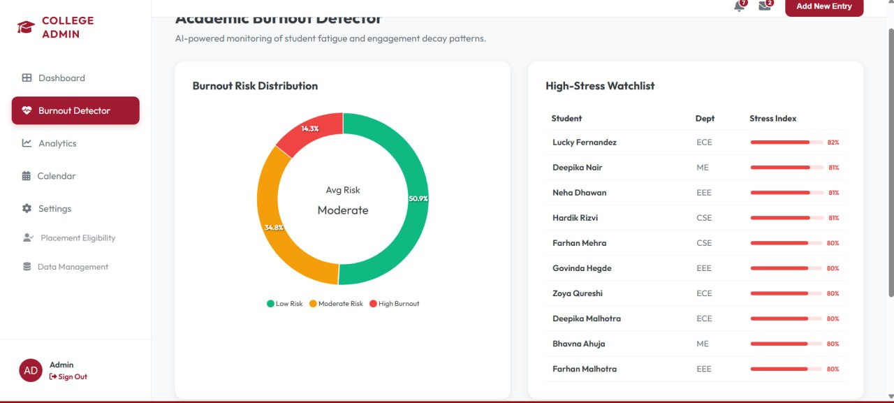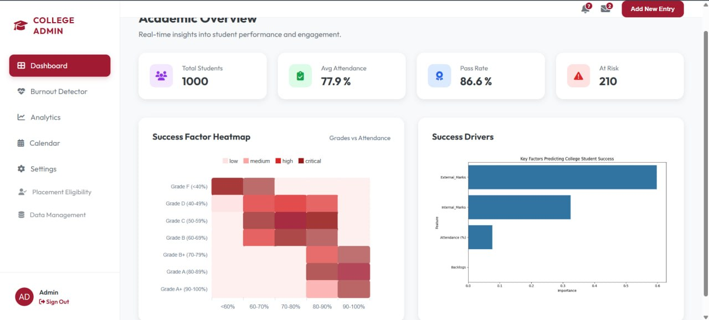

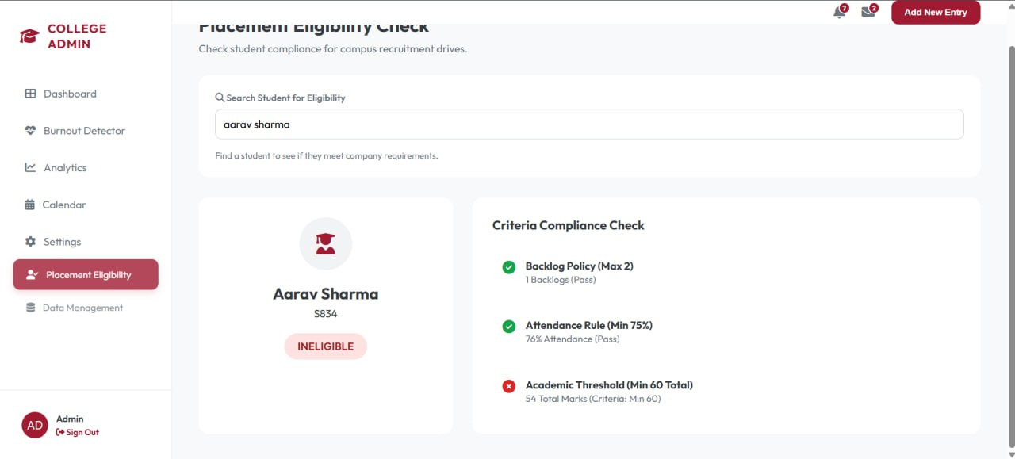

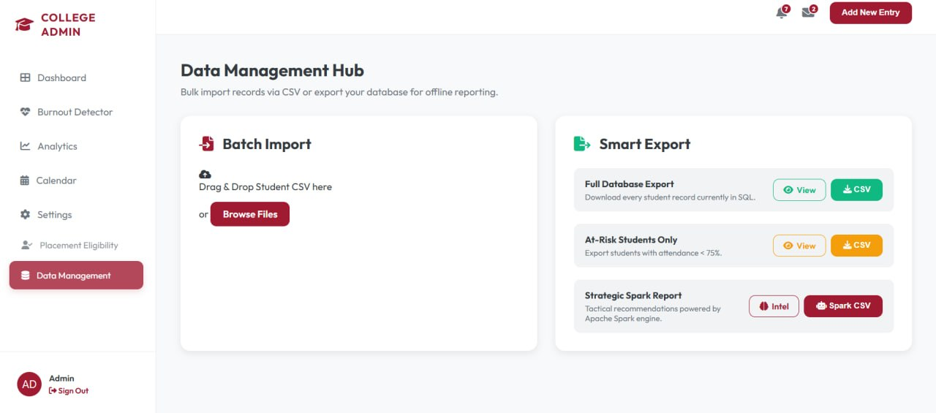

CONCLUSION

The Student Performance Analytics & Prediction System successfully demonstrated how modern data technologies can be effectively used to analyse large volumes of academic data. By utilizing tools such as Apache Spark, SQLite, and machine learning frameworks, the project showcased a scalable and efficient approach to handling, processing, and analysing student performance data. The system was able to extract meaningful insights related to academic trends, student behaviour, and potential risk factors affecting performance.

Through the implementation of data analytics techniques, the project highlighted how student data can be categorized and analysed based on parameters such as attendance, internal marks, external marks, and backlog history. The identification of at-risk students demonstrated the importance of analytics in enabling early intervention and improving academic outcomes. The use of visualization techniques further enhanced understanding by presenting complex data in an intuitive and interactive manner through dashboards.

The integration of a machine learning model added an intelligent layer to the system by enabling the prediction of student outcomes (Pass/Fail). This demonstrated how data-driven systems can support predictive analytics and assist educators in making proactive decisions with minimal manual effort.

Overall, the project successfully achieved its objectives by demonstrating the practical application of Big Data analytics, machine learning, and modern data architectures in the education domain. It provided valuable insights into how educational institutions can leverage these technologies for scalable data processing, improved decision-making, and enhanced student support systems.

This work serves as a strong foundation for future enhancements such as real-time performance monitoring, advanced predictive models, and personalized learning recommendations, making it highly relevant for real-world educational applications.

REFRENCES

References

1. Apache Spark Documentation

Apache Spark
Apache Software Foundation. Apache Spark Documentation.
Available at: https://spark.apache.org/docs/latest/

This reference was used to understand distributed data processing, ETL operations, and large-scale analytics.

2. Python Official Documentation

Python
Python Software Foundation. Python Documentation.
Available at: https://docs.python.org/3/

Referenced for Python programming concepts, data handling, and backend development.

3. Scikit-learn Documentation

Scikit-learn
Scikit-learn Developers. Scikit-learn User Guide.
Available at: https://scikit-learn.org/stable/

Used for implementing machine learning models such as Decision Tree Classifier and understanding model evaluation techniques.

4. SQLite Documentation

SQLite
SQLite Consortium. SQLite Documentation.
Available at: https://www.sqlite.org/docs.html

This reference helped in understanding database design, data storage, and querying for the operational layer.

5. Educational Data Mining and Learning Analytics

Romero, C., & Ventura, S. (2010). Educational Data Mining: A Review of the State of the Art.
This paper provided insights into analysing student data and applying predictive models in education.

6. Big Data Analytics Concepts

Chen, M., Mao, S., & Liu, Y. (2014). Big Data: A Survey.
This reference helped in understanding the role of big data analytics in processing large-scale datasets.

7. Data Visualization Techniques

Few, S. (2009). Now You See It: Simple Visualization Techniques for Quantitative Analysis.
This book helped in understanding effective visualization strategies for interpreting complex datasets.

8. Machine Learning Concepts

Mitchell, T. M. (1997). Machine Learning.
Provided foundational knowledge on machine learning algorithms and predictive modelling.

Online References

https://spark.apache.org/

https://scikit-learn.org/

https://www.sqlite.org/

https://www.kaggle.com (for sample student datasets and inspiration)

https://towardsdatascience.com (for analytics and ML concepts)

https://www.geeksforgeeks.org (for Python, Spark, and data structures reference)

